### **Will the virus kill global capitalism?**

*How the November 2020 US Presidential Election could forge the next direction for the emerging international order*

Jeffry Frieden and Jake Schneider

October 10, 2020

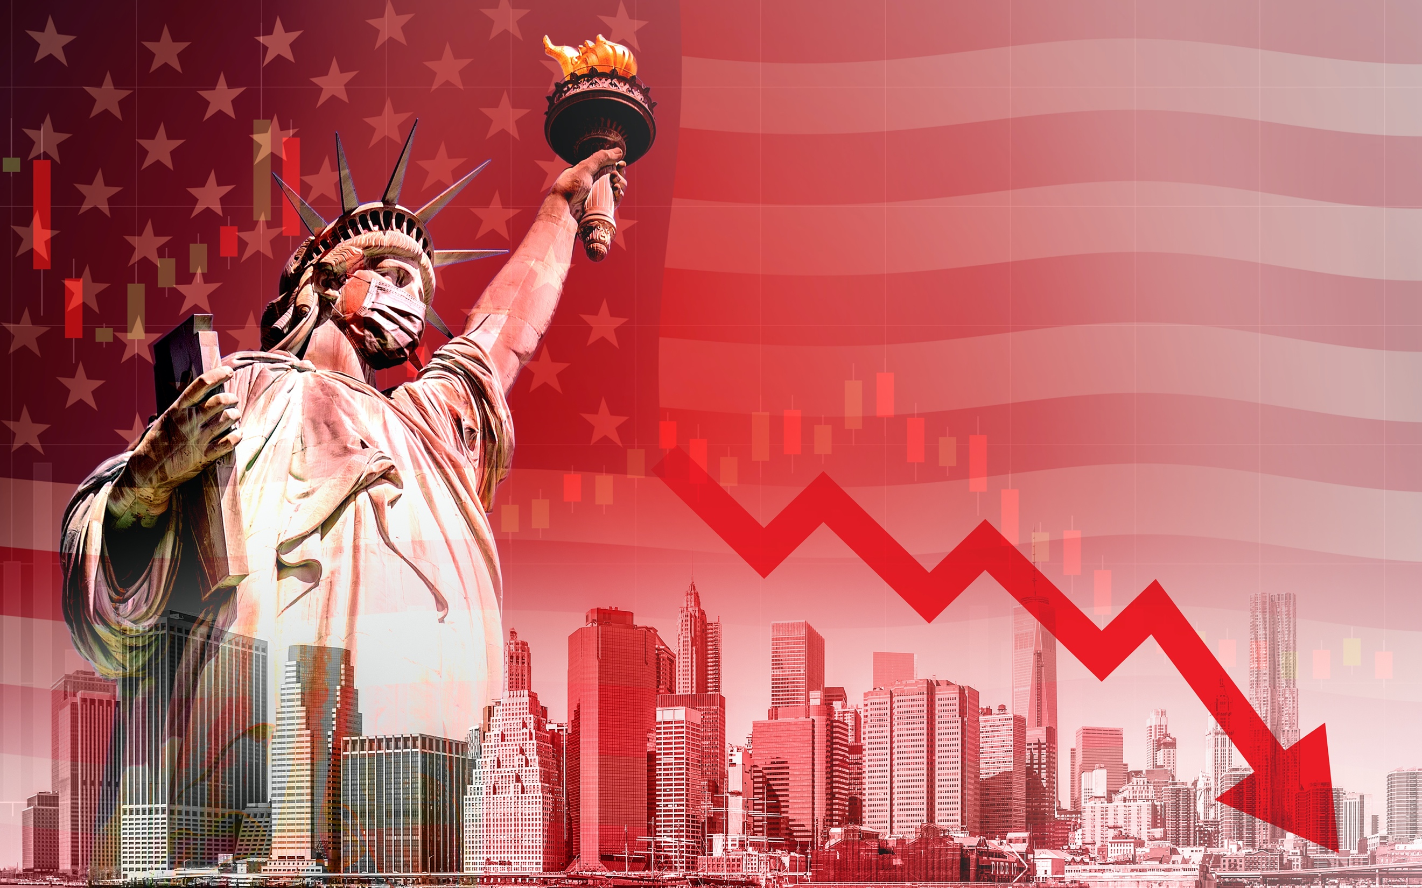

Source: [iStock.com](https://www.istockphoto.com/photo/economic-recession-during-the-coronavirus-outbreak-in-united-states-gm1211810392-351577147)

Will the COVID-19 pandemic mark the end of globalization?

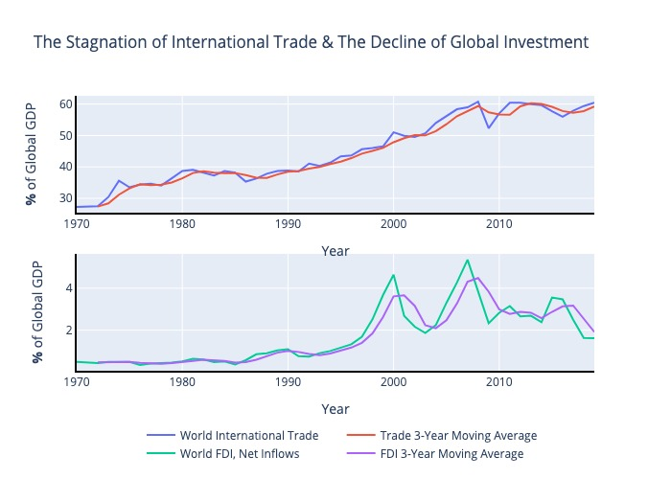

Figure: Jake Schneider & Jeffry Frieden

Source: World Bank World Development Indicators

Code: <https://github.com/jschneids13/COVID-Frieden-Schneider-Article>

<Note: This Graphic is interactive if embedded in html online>

The world we have lived in since World War II has certainly not been perfect, but compared to the terrible preceding decades, it has been politically and economically stable. Over the past decade or so, however, economic and political events have called into question the prevailing global order. A global pandemic has driven international investment and travel to their lowest levels in memory; global trade has stagnated for over a decade. There is reason to wonder if the world we have known is on its last legs.

First the Great Financial Crisis of 2008-2009, and now the Global COVID-19 Pandemic, highlighted and exacerbated forces that may fracture the current international order. The two crises have spurred an upsurge of populism and economic nationalism. They now challenge the trend toward greater global economic and political integration that had previously prevailed.

Two clear views have emerged in much of the world. On one side are those who favor a continuation of globalization in some form, international integration, multilateralism, and political cooperation; on the other side are those who favor nationalist economic policies, unilateralism or bilateralism, and a retreat from international integration. The 2020 election in the United States is a watershed in the battle to determine the future world order.

**What came before**

The current international economic and political order was planned even while World War II was being fought. During the summer of 1944 representatives of more than 40 nations created the Bretton Woods System, aimed at overcoming the bitter economic and political conflicts of the previous thirty years. Led by the United States and populated by such international institutions as the International Monetary Fund, the World Bank, and the General Agreement on Trade and Tariffs (later the World Trade Organization), this infrastructure oversaw post-war reconstruction and subsequent decades of rapid growth.

Global standards of living skyrocketed, even as the world split into the American and Soviet spheres of influence, with the developing world largely relegated to the sidelines.

**Globalization triumphant**

Over the course of the 1980s the trend toward economic integration accelerated. The developed countries embraced anti-inflationary austerity and deregulation. The developing countries jettisoned their prior economic nationalism and opened their economies to the world. Even the centrally planned economies abandoned central planning for the market, and then for the world market. The communist parties of China and Vietnam stayed in power but built globalized market-like economies. The Soviet Union broke apart, and its former components and allies also joined the world economy. The Cold War was over, the West had won, and the future seemed to belong the United States and its allies, and to globalization.

In retrospect, the relative prosperity of the late 1980’s, 1990’s and early 2000’s masked growing social and economic problems. Rising economic inequality and inadequate social policies widened divisions in American society: between the rich and the middle class, between prosperous and distressed regions, among the races.

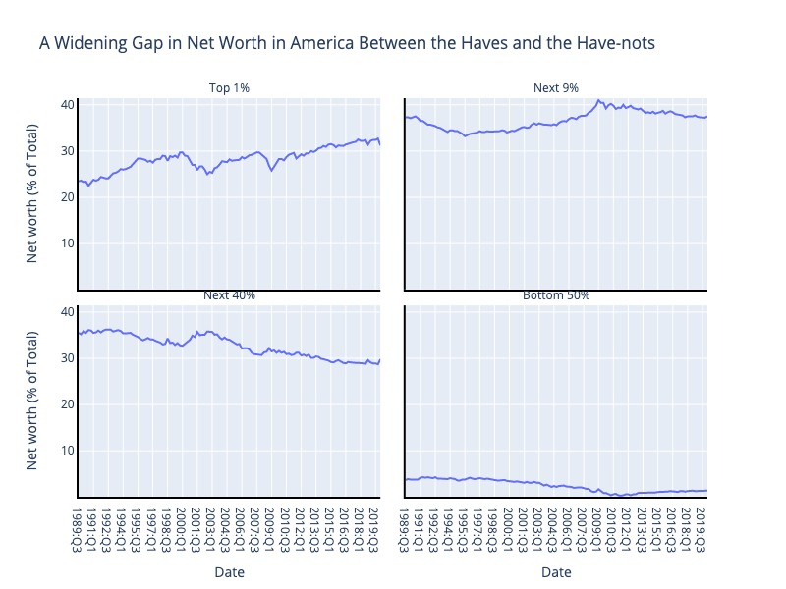

Figure: Jake Schneider & Jeffry Frieden

Source: Federal Reserve Distributional Financial Accounts

Code: <https://github.com/jschneids13/COVID-Frieden-Schneider-Article>

<Note: This Graphic is interactive if embedded in html online>

The American Dream has become elusive. The [share of wealth](https://www.federalreserve.gov/releases/z1/dataviz/dfa/distribute/chart/#range:1989.3,2020.1;quarter:122;series:Net%20worth;demographic:networth;population:1,3,5,7;units:levels) held by the top 1% of Americans has increased from 24% in 1989 to 33% in 2019; the share of assets held by Black, Hispanic and other minorities has remained largely stagnant. In addition, traditional avenues for advancement have become ever more expensive: between 2000 and 2020 [annual tuition](https://www.usnews.com/education/best-colleges/paying-for-college/articles/2017-09-20/see-20-years-of-tuition-growth-at-national-universities) at private universities increased by 154% and by a staggering 181% for out-of-state students and 221% for in-state students at public universities. The two decades leading up to 2007 now seem more like a pale copy of the ‘Gilded Age,’ a lull before the storm.

**Nationalism, Populism, Isolationism**

For decades, the United States has accumulated social and economic problems. Entire regions of the country suffered from a continual loss of well-paying jobs in manufacturing, due both to technological change and to globalization. The gap grew between the prosperous big cities and the struggling rural and ex-urban areas. Workers without a college education fell ever farther behind those with college. When the Great Financial Crisis hit, it sparked an outpouring of anger toward the country’s elites, who appeared not only to have failed to deliver prosperity to large portions of the population, but also seemed not to care.

Hostility toward the elite, the coasts, and the big cities was harnessed by politicians who turned it in the direction of populist nationalism, standing up for “the people” against the elite. The elites had deserted the people, and the people were revolting. The elites had built a multilateral, globalized world that enriched themselves and their allies; the people wanted nothing to do with it. Donald Trump’s presidential campaign of 2016 harnessed much of the anger that had built up over decades and turned it toward an attack on the foundations of the modern international economic and political order. In office, President Trump has eschewed multilateralism, pulled out of treaties and other obligations, attacked the WTO and other international institutions, and revived the isolationists’ 1930s call for “America First.”

Nationalist foreign policy is the new normal for many nations; even the United Kingdom has reversed its international course with [Brexit](https://www.nytimes.com/2016/05/22/business/international/brexit-referendum-eu-economy.html). Domestically, nationalism has been accompanied by populism. Donald Trump incites his base against the [‘radical left’](https://twitter.com/realDonaldTrump/status/1271252020473638912) in America, Viktor Orban routinely invokes [Christian culture](https://foreignpolicy.com/2015/10/31/the-regression-of-viktor-orban-hungary-europe/) in Hungary, and Vladimir Putin regularly castigates [Western liberalism](https://www.ft.com/content/670039ec-98f3-11e9-9573-ee5cbb98ed36) in Russia. Meanwhile, demagogues have further cemented their control; China’s Xi Jinping has declared himself [President for Life](https://www.bbc.com/news/world-asia-china-43361276), and Russia’s Vladimir Putin has [done much the same](https://www.vox.com/2020/7/2/21311144/putin-russia-vote-president-2036). Attacks on the international order from [Brazil](https://www.vox.com/2018/10/31/18042510/bolsonaro-brazil-foreign-policy-venezuela) to [America](https://www.ft.com/content/4bbe8761-81a7-4734-8e1b-3ddfeedcf273) have undermined the international architecture established at Bretton Woods.

**Interwar interlude?**

The troubled decades after World War I saw a similar confluence of nationalist, populist, demagogic and isolationist forces arise in Europe and the United States. The causes were similar: economic and social difficulties, financial crises, and a broad popular sense that ruling coalitions – and ruling classes more broadly – offered little to the masses and showed little interest in addressing their concerns. The similarities to the present are striking; but the differences are just as great. Strong as the nationalist urge is around the world, many of the great powers remain committed to some form of multilateralism, and to economic and political integration: Europe, Japan, Canada, and others seem more baffled by the American turn toward nationalist populism than drawn to it.

**A New World Order?**

Nonetheless, the turn in American domestic and foreign policy may presage a reorganization of the broader world political economy. If the United States continues on its current course, policymakers from Brussels to Beijing, and from Brasilia to Berlin, will have to reassess their place in the world. Will the European Union move to improve relations with Russia, and Japan with China? Will Russia and China work more closely together? Who will prevail in the latest version of the scramble for influence in Africa and the Middle East? If the existing international order begins to crumble, what will replace it?

The answers to most of these questions depend upon the outcome of the 2020 US presidential election. We should not exaggerate the differences between the Republican and Democratic candidates: both are wary of China, ambivalent about trade, and concerned about unreliable allies. But there is a clear difference. The Trump Administration has demonstrated disdain for today’s multilateral international institutions, and distaste for many existing alliances. Joe Biden and the Democrats are no supporters of world government or free trade, but they have a greater commitment to multilateral cooperation and to working with the country’s traditional allies. It is easy to see where a continuation of the Trump presidency will lead American foreign policy, and that it will force major changes in the foreign policies of other major powers; what is hard to know is where all those changes will lead the world. A Biden presidency would be likely to put the country, and the world, back on the course that it had been following before 2016. That course may not be ideal, and in the aftermath of economic crisis and pandemic catastrophe there is serious reason to consider major reforms, but it is a course that is generally understood.

**Conclusion: The Dawning of a New Age?**

The 2020 US presidential election is a symbol of the clash of principles now facing the world; its outcome will help decide the evolution of the world’s economic and political order. A Democratic victory presages, at its most optimistic, an attempt to reform and revitalize both American and international economic and political affairs – to build a better global capitalism. The Democrats have not provided a blueprint for that reconstruction, and it is unlikely that one exists; but that is the direction they will take.

A Republican victory will continue the Trump Administration’s attempt to deconstruct contemporary global capitalism, and to replace it with nationalist populisms around the world. The rise of these nationalist populisms is the result of decades of failures by elites – by the builders of that post-war global capitalism – and their continued inability to propose a more equitable, prosperous, appealing alternative to today’s social and economic distress. The shortcomings of both elites and challengers have been highlighted by a series of failed responses to the gravest global health crisis in a century. COVID may kill global capitalism. But if it does, it will be due to pre-existing conditions.

**About the Authors**

[Jeffry Frieden](https://scholar.harvard.edu/jfrieden) is a professor of government at Harvard University, and the author of [*Global Capitalism*](https://www.amazon.com/Global-Capitalism-Jeffry-Frieden/dp/0393358259/), of which a second updated edition is now available. He specializes in the politics of international economic issues.

[Jake Schneider](https://www.linkedin.com/in/jakewilliamschneider/) is an MBA candidate at the Oxford Saïd Business School, an International Economics graduate from the Harvard Kennedy School, and he has formerly worked at the Brookings Institution, World Bank and Alan Greenspan’s consulting firm.